THE CALL
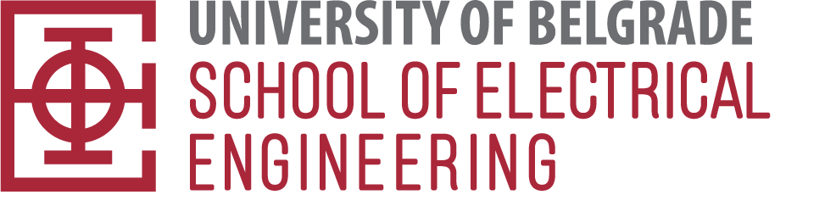

2024/2025.

SCHOOL OF ELECTRICAL ENGINEERING

Address: 73 Bulevar kralja Aleksandra St.
Phone number: +381 11 3218-420
Е-mai: doktorske_konkurs@etf.bg.ac.rs
Website: www.etf.bg.ac.rs

STUDY PROGRAMME FOR WHICH A CALL HAS BEEN ANNOUNCED:
Doctoral academic studies in Electrical Engineering and Computer Engineering in English
(180 ECTS)
NUMBER OF VACANCIES FOR STUDENTS:
The number of students for the enrollment in the study programme in English - Electrical Engineering and Computer Engineering is as follows:
- 20 self-financing students can enroll in the study programme in English.
CONDITIONS:
A person who has completed bachelor academic and master academic studies, i.e., integrated studies with the scope of at least 300 ECTS credits, or completed at least four-year studies according to the regulations that were valid until the enactment of the Law on Higher Education, and an overall average grade of at least 8, can apply for enrollment in doctoral studies. Candidates who have an overall average grade of less than 8 can also apply, if they have completed scientific papers published in journals from the list of the relevant Ministry before enrolling in doctoral studies, in accordance with the general acts of the Faculty or University (specified in the ranking criteria).
A person who has passed the exams in the subjects at the previous levels of study, which represent the necessary preparation for the study area (module) for which he / she is applying, can enroll in doctoral studies.
A person who knows one world language can enroll in doctoral studies.
Prerequisite for enrollment in a study program conducted in English is proof of knowledge of English at a higher intermediate level of competence = B2 - Cambridge Advanced Certificate in English (CAE) or IELTS (International English Language Testing System) or completed high school education in English.

CRITERIA FOR DETERMINING THE ORDER OF CANDIDATES ON THE RANKING LIST:
The order of candidates for enrollment in doctoral studies is determined on the basis of the overall average grade achieved in undergraduate and master academic studies, the length of study in undergraduate and master academic studies, achieved scientific results and other conditions prescribed by the Rulebook on doctoral studies.
The overall average grade of study (OAG) is calculated on the basis of the average grades of study in undergraduate studies (GrUS) and master academic studies (GrMS), weighted by the duration of the study programme in undergraduate and master academic studies expressed in ECTS credits (Uscredit and MScredit):

Overall Average Grade (OAG) = $\frac{GrUS× UScredit+GrMS × MScredit}{UScredit + MScredit}$

For candidates who have completed integrated studies, the average grade achieved in those studies, the length of study and the achieved scientific results are taken.
For candidates who have acquired higher education according to the regulations that were valid until the enactment of the Law on Higher Education, the average grade in undergraduate studies is taken, which includes the thesis, if any, length of study and achieved scientific results.

The candidate who meets the general conditions of the call may also enroll in doctoral studies, if he / she has completed scientific papers in the appropriate scope, i.e., whose total number of points TNoP is at least 8 (eight) calculated as follows:

TNoP = OAG + NoSP / 20

wherein OAG refers to the overall average grade, whereas NoSP refers to the number of points obtained for the achieved scientific papers. Points for scientific papers refer only to papers of category M20-M60 defined by the Rulebook on the procedure and manner of evaluation, and quantitative presentation of scientific research results of researchers (Official Gazette of RS, No. 24/16 and 21/17) (Article 9 of the Rulebook). The maximum number of points for scientific papers, published during the previous two years, that can be achieved is 10.
The order on the unique list is determined based on the number of points NoP
NoP= OAG + NoSP / 20 + 2* (1- M/60) + CF,

wherein M refers to the number of months for which the student has completed the previous levels of study programmes. During the ranking for the budget, candidates can achieve the right to receive the correction factor CF = 1 if they are employed in the title of teaching associate or if the selection procedure for the title of assistant at the School of Electrical Engineering has been initiated.
TUITION FEE:
Tuition fee - studies in English: EUR 10,000.00.

