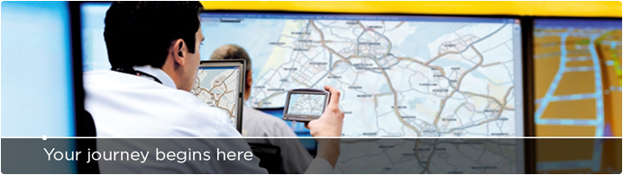

Follow Us
TITLE: Android (Senior) Software Engineer
About YOU!
Are you looking for the next great challenge in your career and are you ready to join our world-class team of Software Engineers. Are you looking for a job where you are fully responsible for building a business and promoting state-of-the-art technology and a world-class brand? Then this might be the perfect opportunity for you!
About the Business Unit/ department:
The Fitness Product Unit is a separate entity within the Consumer Business Unit. It is based in Central London and composed primarily of engineers dedicated to making world class products to enable and motivate people to participate in more sporting activity and to gain more enjoyment from the activity.
The unit has recently announced its first in a long line of new products, and is now looking to be on its success to date.

About the position
In this position you will be responsible for architecture and implementation of Android mobile and tablet applications.

Your primary goals are…

- Developing completely new Android applications
- Designing/Architecture functional modules for communication with web services, UI and external devices communication via set of standard and proprietary protocols
- Building mobile and tablet compatible applications
- Developing and maintaining set of unit tests to support application testing
- Implementing social networks and communities connectivity applications

About YOU in details
You are a dynamic, highly motivated and friendly individual with a strong background in technology. You are a self-starter who feels comfortable working in a dynamic team environment and positively contributes to the future of the business. You work independently to resolve issues. You are passionate about continuous improvement. You do not accept status quo and can challenge mediocrity. With your positive attitude and energy you are able to work in a fast paced, target driven environment and perform well under tight time constraints and clear deadlines.

You are likely to have a university degree, preferably in computer science and are interested in getting your career kick started by joining a dynamic global brand. You are likely to have at least 5 years’ experience in Android applications development. You are used to work in Agile environment. You are able to quickly shift focus. You are analytical and open-minded, with excellent problem solving skills. You love gadgets and follow latest mobile application/devices trends. Having your own applications or applications in which you were involved on Play Store will be considered as an advantage!

You are able to interact with different cultures and levels of colleagues. You are looking forward to joining an excellent team in Belgrade with whom you deliver and celebrate success. You are willing to train others and travel to TomTom worldwide locations to work closely with other teams. You can communicate fluently in English.

Requirements
    - Profound knowledge of latest Android SDK
    - Hands-on experience with Android application development
    - Object Oriented Design and Analysis techniques
    - Experience with creating rich GUI applications on Android devices
    - Experience with REST web services
    - Experience with OO languages (Java, C++)
      - Usage of well-established libraries for achieving standard tasks (social networks connectivity, consuming web services, XML/JSON parsing…)
    - Knowledge of some of the source code versioning systems (Git, Perforce, Mercurial, SVN, CVS)
    - Familiar with Test Driven Development

Our Offer
- The chance to work in a dynamic team with a world-class brand
- Market rate salary & benefits (depending on experience)
- A challenging, fast moving and innovate work environment
About TomTom
Founded in 1991, TomTom is the world's leading provider of in-car location and navigation products and services focused on providing all drivers with the world's best navigation experience. Headquartered in Amsterdam, TomTom has over 3,500 employees and sells its products in over 40 countries.
Our products include portable navigation devices, in-dash infotainment systems, fleet management solutions, maps and real-time services, including the award winning HD Traffic.
By streamlining and integrating our organization we have created a lean and agile structure enabling us to stay close to our customers and substantially improving our time to market. TomTom comprises four business units, Consumer, Automotive, Business Solutions and Licensing.
Interested?
If you would like to be part of this winning international sales support team and help us further position ourselves as the authority in location and navigation solutions, please click here.
We kindly ask you to complete the form and attachments in English.
Pre-employment screening of all external candidates is part of the process.

