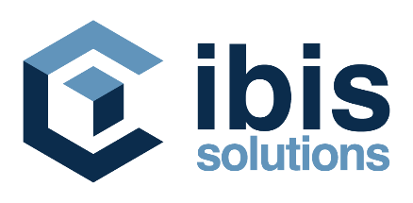

Is currently looking for a
Software Engineer
We are:

Ibis Solutions is part of the Ibis Group, which has been one of the main drivers of the company's digital transformation in the regional market for more than 25 years. Thanks to long-term partnerships with companies such as IBM, Oracle, Red Hat, Ui Path, etc, through system integration projects as well as software development, Ibis Solutions has so far provided significant support to over 300 clients from Southeast Europe.

Due to the significant expansion of our activities, we are looking for a talented SOFTWARE ENGINEER who will join our growing team in Belgrade and focus on system integration of innovative software solutions. Our future colleague is tech savvy, open to learn and delivers great quality.

The scope of your job is:

- Implementation and configuration of OSS/BSS systems developed by leading software companies.
- System administration, maintenance and technical support
- Working closely to the leading telecommunication operators in the region
- Conducting technical presentation and practical demonstration
- Preparation of initial and detailed project documentation

Your qualifications are:

- Basic knowledge of Linux OS
- Understanding and basic knowledge of programming concepts
- Knowledge of the Microsoft Office package
- Effective communication skills
- Proficiency in English

Not mandatory, but good to have:

- Knowledge of SQL and relational databases is a plus
- Knowledge of telecommunication infrastructure and services (network technologies and protocols) is a plus
- Previous experience as Software Engineer is not mandatory, but is a plus

You are:

- Eager to learn, open-minded and hardworking person
- Persistent in acquiring knowledge and competencies
- Detail oriented and self-motivated
- Open to receive and apply constructive feedback
- Able to effectively work in a multi-task environment

Our offer:

- Opportunity for professional development and individual development plan
- Onboarding process with great mentors
- Coaching and training to help you grow
- Working with a highly collaborative and positive environment
- Working closely to the leading telecommunication operators in the region
- Benefit package (FitPass, health insurance, flexible working hours, various sports and team building activities)

Sounds interesting?

If yes, show us what you’ve got and send your CV at career@ibis-solutions.rs until 31.12.2021. Have in mind that only candidates selected for an interview will be contacted.

