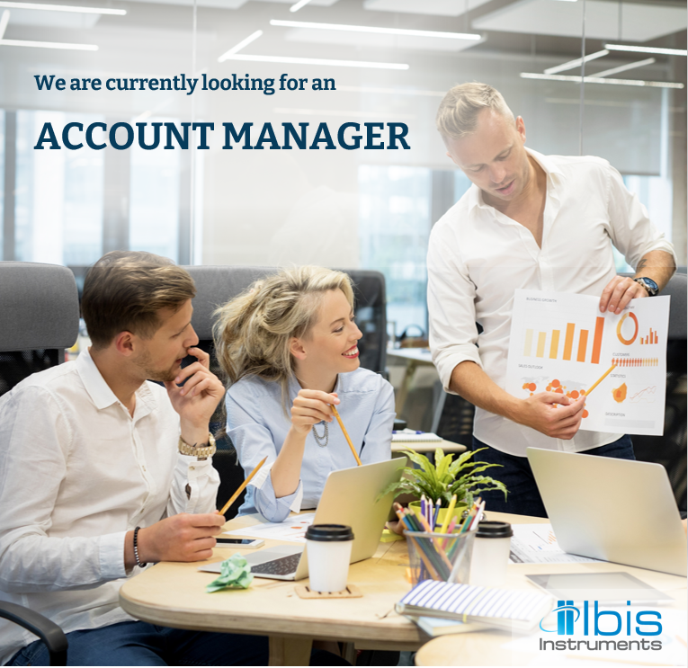

We are:
Ibis Instruments, an ICT company that operates within the Ibis Group in the field of Test and Measurement equipment, offering IP-Wireline and RF-Wireless communication testing and quality of service monitoring solutions.

With headquarters in Belgrade and offices in Ljubljana, Skopje and Banja Luka, Ibis Instruments covers the market of 10 countries in SEE, cooperating with 30+ national telecommunication service providers. During 25 years of continuous development with our partners, leading worldwide T&M corporations such are Keysight Technologies, Viavi Solutions, Fujikura, Microchip, ATDI, TCi, Teoco, Narda, we have built expertise in various technology domains providing consulting, distribution, implementation, and technical support services to more than 500 satisfied customers.

The scope of your job is:
- Establishing and maintaining long-term relationship with customers and partners
- Promoting high-tech solutions in 5G, LTE, WiFi, RF&MW, EMF areas to leading telecommunication companies
- Positioning strategic products to the clients in close cooperation with our technical team
- Developing and executing sales plan

Your qualifications are:
- B.S. in Electrical engineering or Economics with ICT background
- Experience is preferable, but not mandatory
- Fluent in English

Your abilities/skills:
- Communication, negotiation, and presentation skills
- Eager to learn, ambitious and flexible
- Proactive, result-oriented
- Driving license

Our offer:
- Working in a dynamic, stable, and well-organized environment
- Continuous education via internal and vendor’s training platforms
- Personal and professional opportunities for growth
- Working with competent colleagues willing to share their knowledge and experience
- Cooperation with the best international and local companies
- Great opportunity to learn and work with cutting edge technologies
- Flexible working hours
- Private health insurance, FitPass, sick days, various sports and team building activities

If you are looking for a high-performing and friendly work environment, innovative ICT technologies, cooperation with key business leaders on the market, then send your CV for our Account Manager position at career@ibis-instruments.com until 10.09.2021.

* Only candidates selected for an interview will be contacted.

We are looking forward to meeting you!

