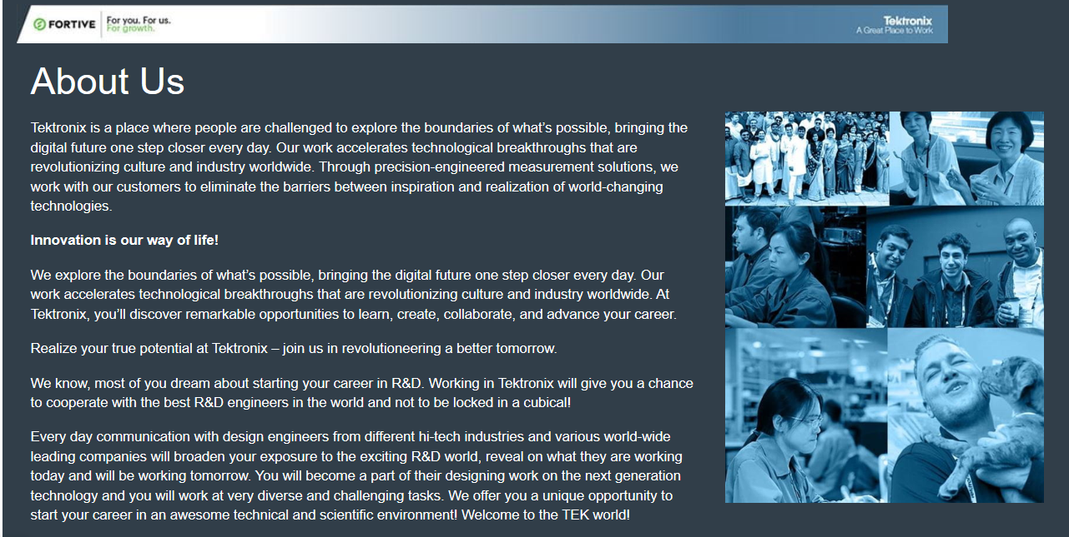
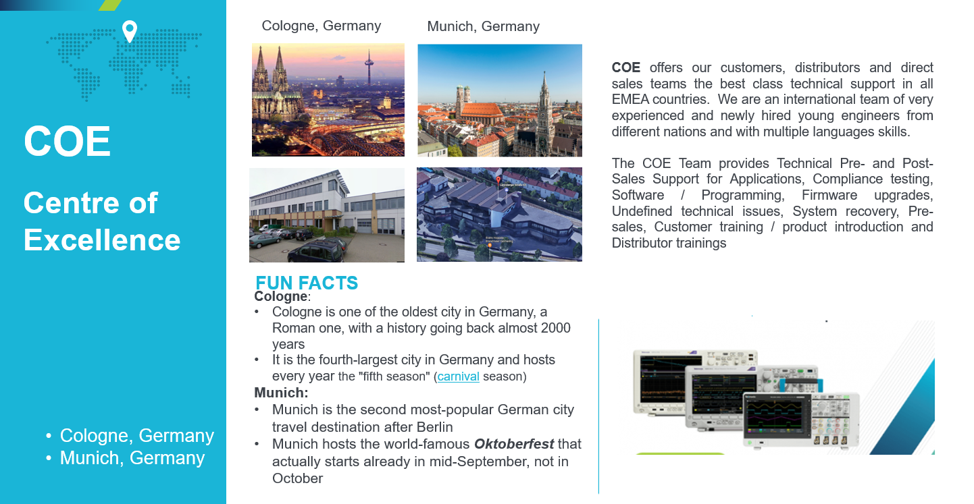

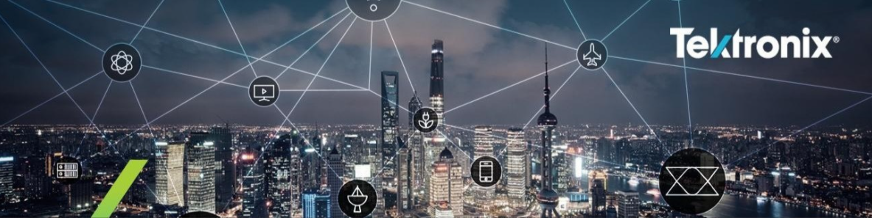
Early Career Engineering Rotational Program with Tektronix - COE
Technical Support Engineer/Junior Applications Engineer (Central and Eastern Europe)
Or
Technical Support Engineer/Junior Account Manager (Central and Eastern Europe)

We believe that cultivating a deeper sense of loyalty and belonging is key to how we attract and retain our best people. By embracing our diverse experiences and views, we are better positioned to deliver results, create innovations that matter, and thrive in today’s changing world. This reality inspires our Inclusion & Diversity vision, We Are More Together, and guides our approach as we all work toward creating great places where our teams work and thrive.

We are offering you the unique opportunity to develop an exciting career in a challenging technical and scientific international environment. At the beginning you will participate in our “Early-in-Career” program. You will join a Team of young talented engineers in the Center of Excellence in Germany (Cologne), where you will learn many different applications and new technologies. Comprehensive on-the-job training and achievement of the next level of expertise will open up various career options for you in our company. Depending on your expertise, mobility, interests and ambitions you could continue your career as an Application Engineer or as a Sales/Account Manager to support our European Sales Organization back in your native country.

Your main tasks will be:
During the first 18-24 month (Technical Support Engineer, Germany):
Solve customer enquiries related to all kinds of applications where test instruments are being used and provide support and consultancy to our customers:
- to operate our equipment and to do measurements
- to test the performance of the products and components
- to support customers remotely with upgrades and software installations
- to develop basic programming examples
- to find solutions of various measurement problems and solve challenging tasks
- to accurately document all customer interactions in Customer Relationship Management system

After 18-24 month (Junior Applications Engineer, CEE)
- Provide technical consultative assistance to the account manager and partners during the sales process to accurately assess potential customers’ needs and determine the appropriate solution from products and services;
- Identify, evaluate and recommend market opportunities consistent with product line objectives, specifically selling into high speed serial, Datacom, Networking, Automotive, and wide variety of other applications where high performance oscilloscopes, arbitrary waveform generators and other equipment consistent with testing high-speed serial technologies.
- Investigate and understand competitors and how to sell against them using our unique value;
- Provide training to internal sales associates and external customers;
- Develop a product support plan that outlines how you will assist in revenue growth for the product families you support;
- Present and demo technology solutions to customers including all hardware, software, and service offerings.
- Provide highly technical engineering support to customers both virtually and inside customer labs.
- Become an expert in certain technology fields and consult customers on the latest developments.
- Work one-on-one with sales personnel to develop customer-specific solutions to complex applications problems.
- Become well versed in the full Tektronix portfolio offering and work closely with sales partners to identify all possible business opportunities across performance, mainstream, & entry scopes, arbitrary waveform generators, spectrum analyzers, source measurement units, digital multimeters, etc...

“OR” (Junior Account Manager, CEE):

- Secure growth of the Tektronix business and taking share from the competition
- Make partner and customer visits, provide sales presentations for all Tektronix/Keithley product lines and training to the customers
- Develop strong relationships with distribution partners, drive distribution and regional sales activities through making joint customer visits, analysing new paths to further market development and customer penetration, and supporting local marketing activities
- Identify Focus Accounts and ensure needed support level
- Cooperate with Tektronix Distribution Account Manager, Application Engineers, Marketing and other key stakeholders, consistently leverage and engage resources to execute and provide excellence in supporting customers and winning business.
- Contribute to sales forecast and robust funnel growth
- Provide regional & customer update & status reports to regional Sales Director
- Learn and advise on the regional market trends and conditions and focus areas
- Respect and follow the company values and processes and act in accordance with them

What we expect from you:
- Technical Degree e.g. Electronic Engineering or similar field with good knowledge of Test & Measurement, RF or Telecommunication
- Enthusiasm to Test and Measurement world
- Interest in latest technical evolutions and applications (standards for High Speed Serial Data buses, e.g. USB 3.0, HDMI, SATA, PCI Express, 10GB-KR etc.), wireless communication, Radar, optical data communication as 100GBE/400GBE, TDR, etc.)
- Knowledge of Programming languages (i. e. Matlab, LabVIEW, Python, C++/C#)
- Willingness to work with customers
- Good communication and presentation skills
- Ability to work independently and with little supervision
- Flexibility and mobility
- Readiness to work in the international environment
- Fluency in English
- Fluency in any East-European language

When you join Tektronix and Fortive, you will work in an extraordinary team, learning with and from great people, where diversity and inclusion is celebrated. You will have the opportunity to do work that makes a difference in the world. You will be trusted and empowered to contribute in meaningful ways with visibility and accountability. We are obsessed with our customers and have a commitment to transparency, unending learning and growth to accelerate progress and innovation. Join us for the excitement of a startup with a history of success! For You. For Us. For Growth.
Tektronix is an equal opportunity employer. We evaluate qualified applicants without regard to race, color, national origin, religion, gender, age, marital status, disability, veteran status, sexual orientation, gender identity, or any other characteristic protected by law. Candidates with less education/experience may be considered for other opportunities.
Fortive Corporation Overview
Fortive is a diversified industrial growth company comprised of global businesses that are recognized leaders in attractive markets. With more than $6 billion in annual revenues, Fortive’s well-known brands hold leading positions in field instrumentation, transportation, sensing, product realization, automation and specialty, and franchise distribution.
Fortive is headquartered in Everett, Washington and employs a team of more than 24,000 research and development, manufacturing, sales, distribution, service and administrative employees in more than 40 countries around the world. Our team grows by tackling challenges that accelerate progress and further their careers. With a culture rooted in continuous improvement, the core of our company’s operating model is the Fortive Business System. For more information please visit: www.fortive.com
Watch our Video: https://de.tek.com/landing-page/emea-careers
Apply online here - link

